Contact: Jonina Costello / jcostello@full-throttlecom.com
Jason Bear / jbear@full-throttlecom.com
Phone: (805) 529-3700

ONTARIO KNIFE COMPANY® INTRODUCES NEW CERBERUS FOLDER

Featuring a D2 Steel Blade and Titanium Handle, This Knife Lives Up to Its Legendary Name

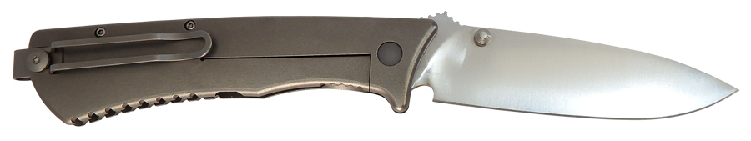
Knife innovator Ontario Knife Company® (OKC®) has unveiled a superior performing, beautifully designed new folding knife built to handle any situation from hunting and fishing to camping and tactical. Named after the mythical three-headed beast that guards the gates of the underworld, the new Cerberus Folder features a D2 tool-steel blade with a titanium handle and frame lock, making it durable enough to tackle even the most punishing tasks.

“The OKC Cerberus Folder has the versatility of an everyday carry folding knife with the spirit of a fixed blade,” observed Deneb Pirrone, Vice President of Sales & Marketing for OKC. “Designed as a counterpart to the original OKC Cerberus, this minimalist tactical folder is overbuilt and purpose-driven for use in the field.”

The OKC Cerberus Folder has an overall length of 9.125-inches with a 3.75-inch blade that’s 0.130-inches thick—ideally sized for daily use and a variety of applications. This full-grind, spear point blade is made of incredibly robust D2 steel and features a satin finish. The Cerberus Folder is engineered down to the edge geometries, precision manufactured, and backed by OKC’s lifetime warranty.

The frame locking mechanism of the OKC Cerberus Folder is supported by the strength of the knife’s titanium handle, which features an ergonomic design, gimping for superior purchase, and a smooth bead-blast finish. Multitaskers and southpaws will appreciate the ambidextrous thumb studs that allow for singlehanded opening in either hand. Completing the EDC package is the knifes narrow profile coupled with its naturally lightweight nature and reversible pocket clip — all of which allow for ease of carry in your pocket, vest, jacket, or backpack.

The OKC Cerberus Folder is engineering in the USA, made in Taiwan, and has an MSRP of $164.95.

Founded in 1889, the Ontario Knife Company® is an award-winning knife, cutlery, and tool manufacturer operating out of Upstate New York for over 127 years. OKC® produces a wide range of tools, including cutlery and kitchenware, hunting and fishing knives, machetes, survival and rescue equipment, science and medical tools, and tactical knives. OKC has a long tradition of building knives and tools for the U.S. military, producing high quality equipment that has seen continuous service since WWII. In addition to being a major supplier to the U.S. Armed Forces, OKC leverages a network of distributors, dealers, and major commercial retailers to sell its products nationwide and internationally. OKC’s custom manufacturing division Jericho Tool® offers capabilities including a broad-spectrum of injection molding, tool and die, and machining operations to provide white label and OEM manufacturing services for consumer and industrial goods. Collectively OKC’s products and manufacturing services reach the house wares, sporting goods, tactical, law enforcement & first responders, education, science & medical, and industrial & agricultural industries.

For more information about Ontario Knife Company and its industry-leading line of advanced knives, machetes, edged products and specialty tools, contact Ontario Knife Company at P.O. Box 145-26 Empire Street · Franklinville, NY 14737 · Telephone (716) 676-5527 · Or visit www.ontarioknife.com. The Ontario Knife Company is a subsidiary of publicly traded Servotronics Inc. (NYSE - SVT).

Editor’s Note: For hi-res images and releases, please visit our Press Room at www.full-throttlecommunications.com

