ONTARIO KNIFE COMPANY® EXPANDS WRAITH SERIES WITH
NEW WRAITH ICE FOLDING KNIFE

Sleek Design and Lightweight Profile Combine for the Perfect EDC Pocket Knife

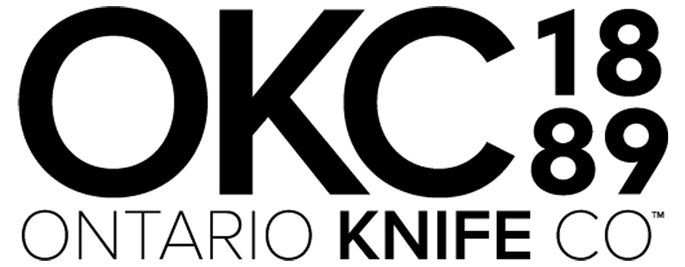
Franklinville, NY – When Ontario Knife Company® (OKC®) introduced the Wraith folder back in 2018, it quickly became a fan favorite every day carry, and for good reason. With a slim, lightweight profile and quality construction, it’s no surprise OKC decided to expand on the popular knife series in 2020 with a sleek new addition that’s as cool as ‘ice’ —the new OKC Wraith Ice folder.

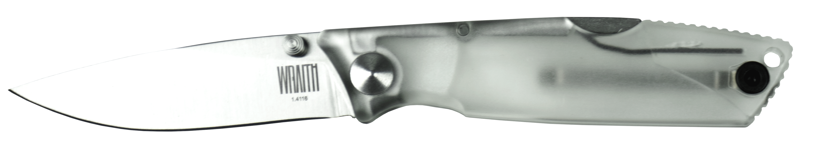
“The Wraith has been extremely popular thanks to its compact, modern design and incredible price point,” said Kenneth Trbovich, President and CEO of Ontario Knife Company. “We’re excited to expand on the series by delivering the same quality folder with a cool clear handle, providing even more options for an every day carry pocket knife to our customers.”

With a classic drop-point blade incorporated into a lock-back design, the Wraith is a modern take on a classic folder. Its clear translucent handle takes its modern elements to another level, partnering perfectly with its AUS-8 stainless steel blade with 57-59 HRC hardness rating for extreme durability and outstanding edge retention.

The OKC Wraith Ice measures 6.5 inches when fully deployed, with a 2.6-inch plain edge blade with satin finish. The blade is equipped with a thumb-stud for ease of opening and its incorporated lock mechanism easily secures the blade open. The blade release is located on the rear of the handle, making it easy to close the blade when you want it shut. The handle is constructed of durable plastic, and is contoured for a secure grip. This multi-purpose knife slides easily into your pocket for a convenient carry, making usage extremely versatile and handy for every day use.

Founded in 1889, the Ontario Knife Company® is an award-winning knife, cutlery, and tool manufacturer operating out of Upstate New York for over 125 years. OKC® produces a wide range of tools, including cutlery and kitchenware, hunting and fishing knives, machetes, survival and rescue equipment, science and medical tools, and tactical knives. OKC has a long tradition of building knives and tools for the U.S. military, producing high quality equipment that has seen continuous service since WWII. In addition to being a major supplier to the U.S. Armed Forces, OKC leverages a network of distributors, dealers, and major commercial retailers to sell its products nationwide and internationally to over 35 countries. OKC’s custom manufacturing division Jericho Tool®, advances capabilities including a broad-spectrum of injection molding, tool and die, and machining operations to provide white label and OEM manufacturing services for consumer and industrial goods. Collectively OKC’s product lines and manufacturing services reach the house wares, sporting goods, tactical, security, law enforcement & first responders, education, science & medical, and industrial & agricultural industries.

For more information about Ontario Knife Company and its industry-leading line of advanced knives, machetes, edged products and specialty tools, contact Ontario Knife Company at P.O. Box 145-26 Empire Street · Franklinville, NY 14737 · Telephone (716) 676-5527 · Or visit www.ontarioknife.com. The Ontario Knife Company is a subsidiary of publicly traded Servotronics, Inc. (NYSE MKT - SVT).

Connect with Ontario Knife Company on social media:

