WILEY X ADDS NEW HD TANK TO HARLEY-DAVIDSON® PERFORMANCE EYEWEAR LINE

New Climate Control™ Model is Rally Ready and Road Safe

The Harley-Davidson® Performance Eyewear Line has a bold new model that embodies everything this growing brand stands for — superior vision under real-world riding conditions, advanced protection against the hazards of the road, and aggressive styling that fits the free-wheeling spirit of Harley-Davidson fans everywhere.

The new HD Tank is all these things, providing riders with a range of frame and lens combinations to best suit their environment, the type of riding they do and their personal sense of style. As a member of Wiley X’s Climate Control™ Series, the new HD Tank features a patented, removable Facial Cavity Seal™ that protects riders’ eyes from wind, dust and peripheral light, as well as from the negative affects of Dry Eye syndrome. A variety of lenses developed for the Harley-Davidson Performance Eyewear Line provide riders with clear, undistracted vision under a range of conditions, to enhance situational awareness and improve riding safety.

All new HD Tank models are designed to provide ideal fit and wearing comfort for medium to large head sizes.
HD Tank models HDTAN05 and HDTAN08 feature Wiley X’s exclusive LA™ Light Adjusting Lenses that quickly and automatically lighten or darken based on light conditions. This popular choice always provides riders with the optimum tint in the ever-changing conditions encountered on the road — or when hanging out with friends when the long ride is done.

The HD Tank is also offered with Silver Flash (Smoke Grey) lenses (Model HDTAN01) fitted into a distinctive Big Blue Pearl frame that looks great, feels great and provides all-day wearing comfort. Model HDTAN04 features a Matte Black Frame paired with Wiley X’s sophisticated, partial polarized PPZ™ lenses exclusive to the Harley-Davidson line. These lenses provide riders with the glare-reducing benefits of polarization without the vision-distorting pitfalls of traditional polarized lenses. These unique lenses help riders “read the road” better — even through a windscreen — while providing a clear view of gauges. All Harley-Davidson Performance Eyewear models provide 100% protection against the sun’s harmful UVA and UVB rays.

Speaking of protection, all Harley-Davidson models feature shatterproof Selenite™ lenses and nearly indestructible frames, meeting stringent ANSI Z87 High Velocity and High Mass Impact Safety standards. Riders can take to the roads and highways with confidence their eyes are well protected against hazards ranging from airborne debris to low-hanging limbs to rocks kicked up by passing vehicles. In addition, nearly all Harley-Davidson® Performance Eyewear styles are Rx-Ready, providing the ideal no-compromise solution for motorcycle enthusiasts who need to wear prescription lenses.

To learn more about the new Climate Control HD Tank — or the full line of Harley-Davidson® Performance
Eyewear designed for riders and sold through authorized Harley-Davidson® dealers nationwide — contact
Wiley X, Inc. at 7800 Patterson Pass Road, Livermore, CA 94550 • Telephone: (800) 776-7842 • Or visit online at
h-dsunglassesbywileyx.com.

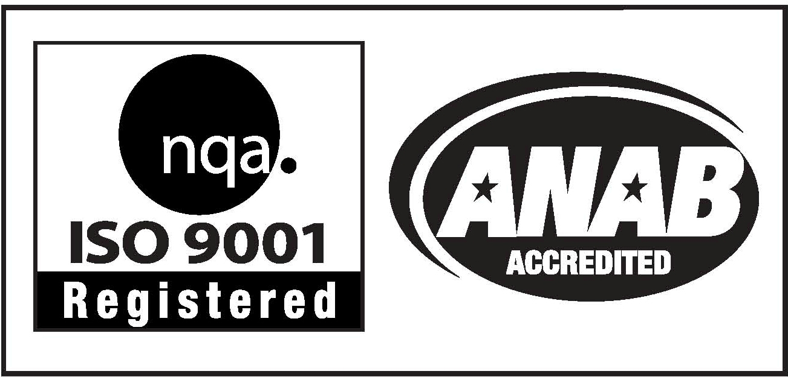
Editor’s Note: For hi-res images and releases, please visit our online Press Room at www.full-throttlecommunications.com.

